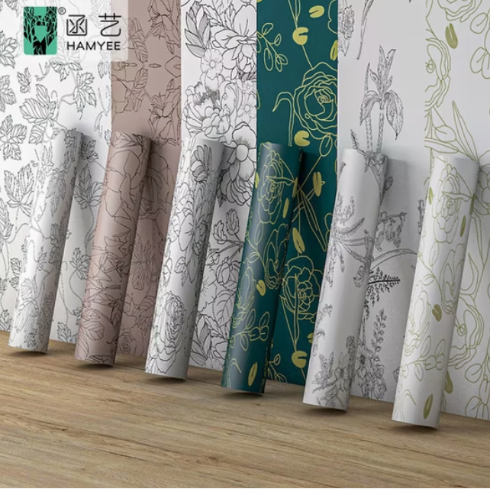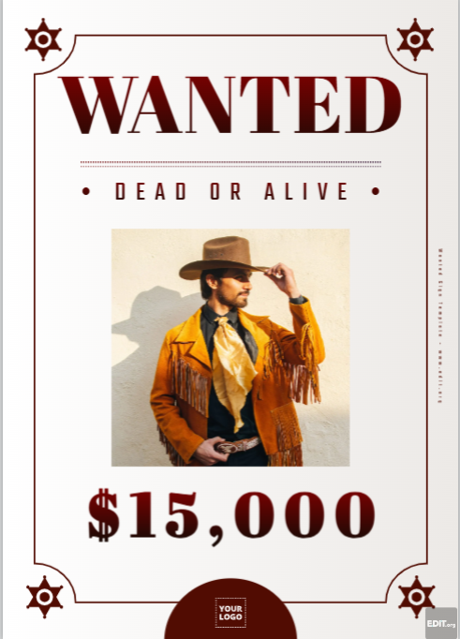

Part 1 - Match the word (A–F) with the meaning (1–6).

Words:
A. Flexing

B. Wholesome

C. Highlight

D. Interest rate

E. Wallpaper

F. Fugitive

Meanings:

Healthy, good for you, or good for your mind.

The extra money the bank asks when you borrow money.

Showing off, showing your strength or something you are proud of

A person running away from the police.

The best or most important part.

Paper or picture you put on a wall or phone screen.

Part 2 – Fill in the blanks

1. My grandma made a very ________ soup with vegetables.

2. The police are looking for a ________.

3. The best ________ of the trip was meeting new friends.

4. He is ________ his muscles in the mirror.

5. The bank increased the ________ on my loan.

6. I put a new ________ on my phone yesterday

